Project Name

Overheating Risk Assessment

**Issue ##**

Day Month Year

|  |  |  |
| --- | --- | --- |
| **ISSUE HISTORY** | | |
| **Issue** | **Date** | **Description** |
|  |  |  |
|  |  |  |
|  |  |  |
|  |  |  |
|  |  |  |

|  |  |
| --- | --- |
| **MAX FORDHAM LLP TEAM CONTRIBUTORS** | |
| **Engineer (Initials)** | **Role** |
| [Remove this table completely for Planning submission] |  |
| [Initials] |  |
| [Initials] |  |
|  |  |
|  |  |

**Max Fordham LLP**Max Fordham LLP  
42/43 Gloucester Crescent  
London  
NW1 7PE

**T** +44 (0)20 7267 5161

[maxfordham.com](http://www.maxfordham.com/)

Max Fordham LLP is a Limited Liability Partnership.

Registered in England and Wales  
Number OC300026.

Registered office:   
42–43 Gloucester Crescent  
London NW1 7PE

This report is for the private and confidential use of the clients for whom the report is undertaken and should not be reproduced in whole or in part or relied upon by third parties for any use whatsoever without the express written authority of Max Fordham LLP

© Max Fordham LLP

**Contents**

1.0 Summary 4

2.0 Introduction 5

2.1 Purpose of report 5

2.2 Site description 5

3.0 Methodology 7

3.1 CIBSE TM59 7

3.2 Adaptive comfort 7

3.3 Weather Files 9

4.0 Model Description 10

4.1 Software 10

4.2 Site Location and orientation 10

4.3 Sample units 10

4.4 Geometry 11

4.5 Fabric 12

4.6 Glazing and shading 13

4.7 Ventilation 13

4.8 Internal gains 14

4.9 Weather files 16

4.10 Comfort category 16

5.0 Results 17

6.0 Conclusions and Recommendations 21

7.0 Appendices 22

# Summary

This report presents an overheating risk assessment undertaken on the proposed [development description] at [Site Address, City]. The assessment has been carried out using IES 2019 dynamic thermal modelling software, following the methodology set out in CIBSE TM59:2017.

The model incorporates [description of features, e.g. opening windows, acoustic louvres, external shading].

The results show [description of results and recommendations].

# Introduction

## Purpose of report

This report presents an overheating risk assessment undertaken on the proposed [description of the development] at [Site Address, City, Postcode].

The purpose of the assessment is to establish whether internal conditions are likely to remain comfortable during the summer, for both current and predicted future climates.

Dynamic thermal modelling is used in the assessment, following the procedures set out in ‘CIBSE TM59: 2017 Design methodology for the assessment of overheating risk in homes’.

## Site description

[Description of the site – location, nearby buildings that provide shading, acoustic or air quality constraints etc]

[Maps (OSM is recommended), plans (showing north arrow) and images showing the site location and proposed development, e.g. as below]

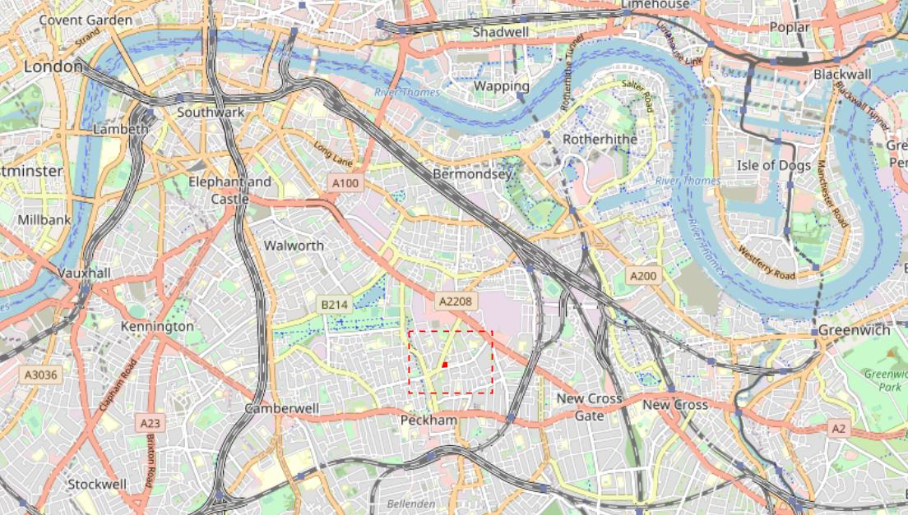

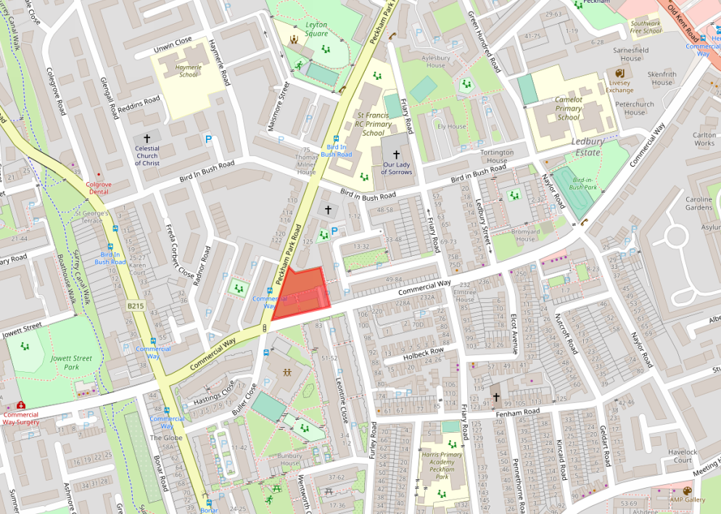

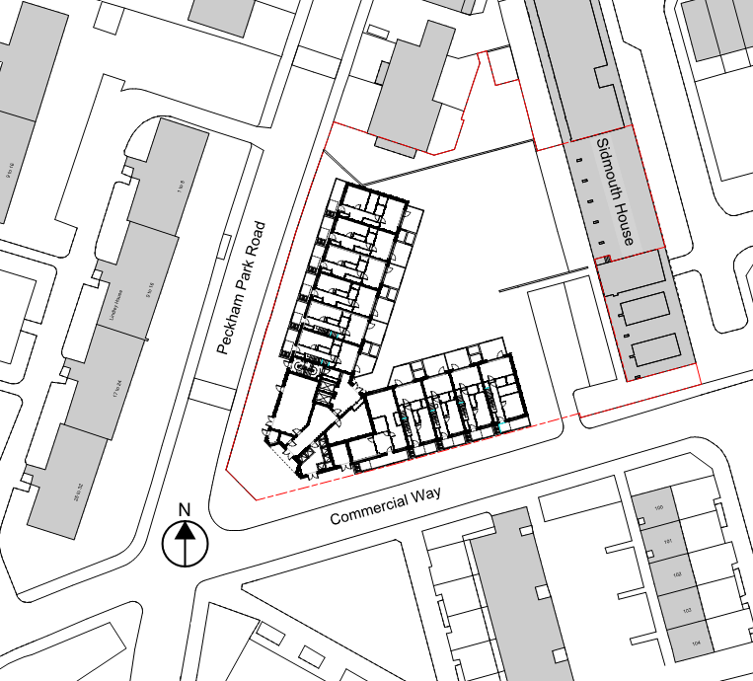

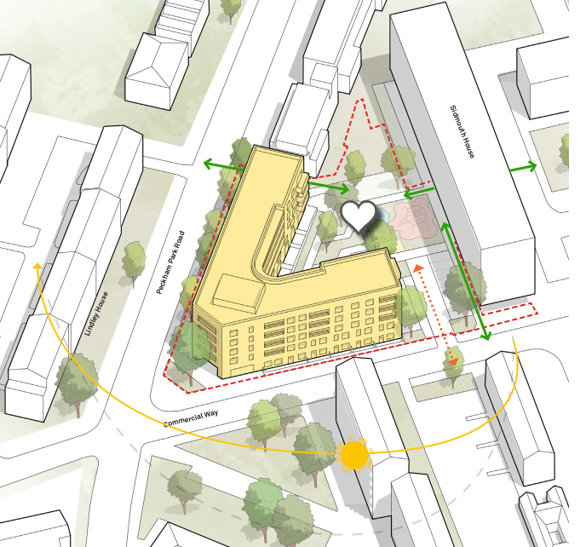

# Methodology

## CIBSE TM59

‘CIBSE TM59: 2017 Design methodology for the assessment of overheating risk in homes’ defines a standardised approach to predicting overheating risk for residential building designs, using dynamic thermal analysis.

The methodology provides a set of occupancy, lighting and equipment profiles that represent reasonable usage patterns for a home, suitable for evaluating overheating risk. It also provides guidance for other model inputs, such as the operation of openable windows and solar shading devices.

TM59 sets different assessment criteria depending on whether the dwelling is predominantly naturally ventilated or mechanically ventilated. These criteria draw upon ‘CIBSE TM52: 2013 The limits of thermal comfort: avoiding overheating in European buildings’ and ‘CIBSE Guide A: Environmental design’.

For predominantly naturally ventilated homes there are two criteria, with application depending on the room type:

* **Criterion a**: For living rooms, kitchens and bedrooms: the number of hours during which ΔT is greater than or equal to one degree (K) during the period May to September inclusive shall not be more than 3% of occupied hours. ΔT is the difference between the *operative temperature in the room* and the *maximum acceptable temperature* (CIBSE TM52 Criterion 1: Hours of exceedance).
* **Criterion b**: For bedrooms only: the operative temperature from 10 pm to 7 am shall not exceed 26°C for more than 1% of annual hours. Note: 1% of the annual hours between 10pm and 7pm is 32 hours, so 33 or more hours above 26 °C will be recorded as a fail.

For predominantly mechanically ventilated homes there is a single criterion, applicable to all occupied rooms:

* **Criterion c**: For living rooms, kitchens and bedrooms: the operative temperature should not exceed 26°C for more than 3% of the annual occupied hours (CIBSE Guide A).

## Adaptive comfort

TM59 criterion a is based on the adaptive model of thermal comfort, as discussed in TM52. This assumes that a person’s comfort threshold changes as they adapt to the environment they normally encounter. For example, during an extended period of warm weather, the air temperature at which a person feels comfortable increases.

Meta-analyses of a large number of studies have determined a range of comfortable internal temperatures exist for naturally ventilated buildings. The upper limit of this range, or maximum acceptable temperature (Tmax) is defined as follows:

Tmax = Tcomf + Tmargin

The (average of all studies) comfort temperature (Tcomf) is defined in terms of the exponentially weighted running mean of the daily mean outdoor air temperature (Trm):

Tcomf = 0.33 Trm + 18.8 (°C)

The acceptable temperature margin (Tmargin) is defined in terms of the type of building and its use, as shown in the table below.

|  |  |  |  |
| --- | --- | --- | --- |
| Category | Explanation  (from CIBSE TM52:2013 Table 2) | Acceptable temperature margin Tmargin (°C) | Applicability to TM59 |
| I | High level of expectation only used for spaces occupied by very sensitive and fragile persons | 2 | Care homes and accommodation for vulnerable occupants |
| II | Normal expectation  (for new buildings and renovations) | 3 | Default TM59 recommendation |
| III | A moderate expectation  (used for existing buildings) | 4 | Not to be used |
| IV | Values outside the criteria for the above categories  (only acceptable for a limited periods) | > 4 | Not to be used |

[Create custom version of the graph below, showing Tcomf average line and Tmax lines for cat. I, II, III]

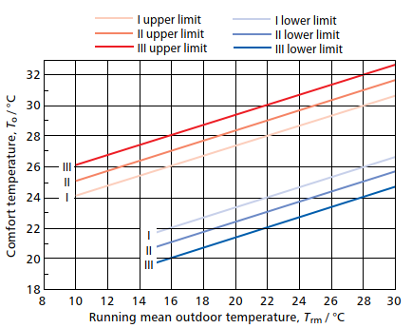

[Add description of the impact of increased air velocity, e.g. due to ceiling fans (can be deleted from report if not relevant to project)]

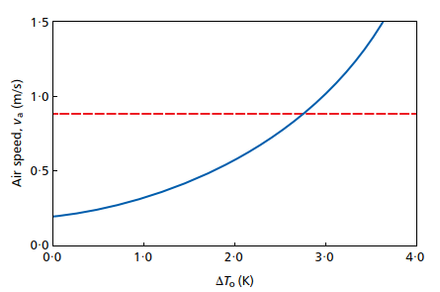

## Weather Files

Weather files contain location-specific data used to drive dynamic thermal modelling. Each file contains data for temperature, wind speed & direction and solar irradiation for each hour of the year. The most appropriate weather file location and type must be selected based on the demands of a project.

CIBSE Design Summer Year (DSY) weather files contain data measured in years with a particularly warm summer and are suitable for use in overheating risk assessments. These are available for 16 different sites across the UK. There are three types of DSY available for each location, selected using the methods described in ‘CIBSE TM49: Design Summer Years for London‘. These three types represent summers with different types of hot events:

* **DSY1: A year with a moderately warm summer**

Summers will have a 1-in-7 chance of being equal or hotter than this DSY.

* **DSY2: A year with a very intense single warm spell**

A summer with a heat event the same length of that of DSY1 but with a higher intensity.

* **DSY3: A year with a prolonged period of sustained warmth**

The heat event is more intense than that of DSY1 but less intense than that of DSY2. It has a longer duration than that of DSY1.

‘Current climate’ DSY files are based on real data measured within the period 1984-2013. ‘Future climate’ files are also available, which are created by morphing the current climate files based on climate change predictions for a range of future periods. The available time periods represent a 30-year period centred on the stated decade:

* 2020s (2011-2040)
* 2050s (2041-2070)
* 2080s (2071-2100)

The future weather files are available for combinations of three greenhouse gas emissions scenarios (low, medium, high) and three levels of probability (10%, 50%, 90%).

TM59 states that, as a minimum, the overheating risk assessment should pass using DSY1 for the 2020s, high emissions, 50% probability scenario.

Additional files should also be used to assess future climates (DSY1 for the 2050s and 2080s) and heatwave conditions (DSY2 and DSY3, for the 2020s) if deemed appropriate.

# Model Description

## Software

Dynamic thermal modelling has been carried out using Integrated Environmental Solutions Virtual Environment (IES VE) version 2019.2.0.0. This software complies with the requirements of ‘CIBSE AM11: 2015 Building performance modelling’.

## Site Location and orientation

As shown in Section 2.2, the site is located [description of the site location, e.g. to the south west of example street]. The proposed development faces [description of orientation].

## Sample units

[Description of the units/rooms that have been modelled and why selected]

[Table and layouts detailing units that have been modelled, e.g. as below]

|  |  |  |  |  |  |
| --- | --- | --- | --- | --- | --- |
| Unit Reference | Unit Type | Dwelling Type | Size | Principal Orientation | Floor |
| A_00_01 | B | Maisonette | 4B6P | North-west | Ground/First |
| A_00_02 | A | Maisonette | 3B5P | North-west | Ground/First |
| A_00_10 | A | Maisonette | 3B5P | South | Ground/First |
| A_00_11 | B | Maisonette | 4B6P | South | Ground/First |
| A_04_01 | G | Flat | 2B4P | North-west | Fourth (Top) |
| A_04_02 | H | Flat | 2B3P | South-east | Fourth (Top) |
| A_04_03 | F | Flat | 1B2P | North-west | Fourth (Top) |
| A_04_06 | D | Flat | 2B3P | South | Fourth (Top) |
| A_04_08 | F | Flat | 1B2P | South | Fourth (Top) |
| A_04_09 | G | Flat | 2B4P | South | Fourth (Top) |
| A_04_10 | H | Flat | 2B3P | North | Fourth (Top) |

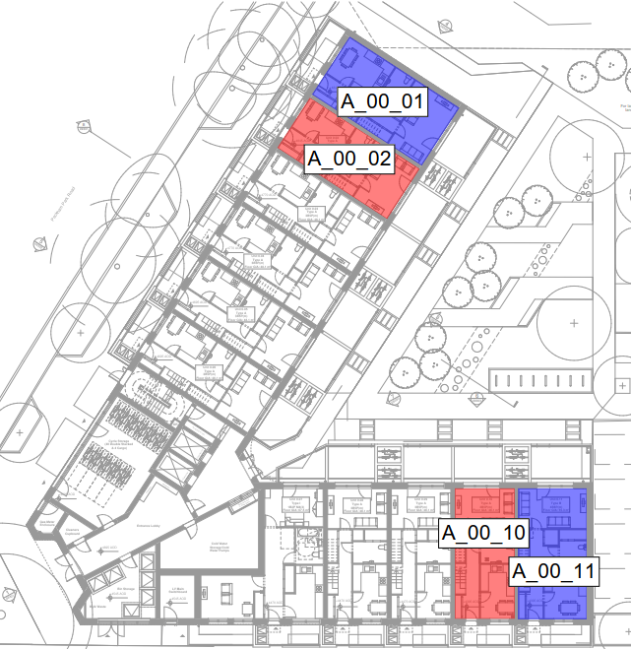 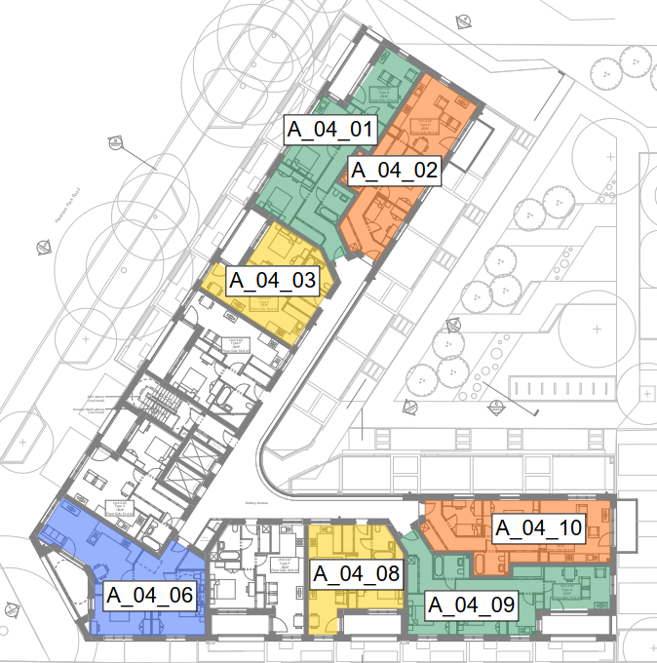

## Geometry

The IES model geometry (shown in the images below) has been created based on [description of architect information that model is based on, e.g. architect drawings (or Revit mode) received dd/mm/yyyy]. The geometry includes all adjacent and nearby existing buildings that may provide shading to the proposed dwelling.

[Images of the IES model, showing all elevations plus adjacent buildings, e.g. as below]

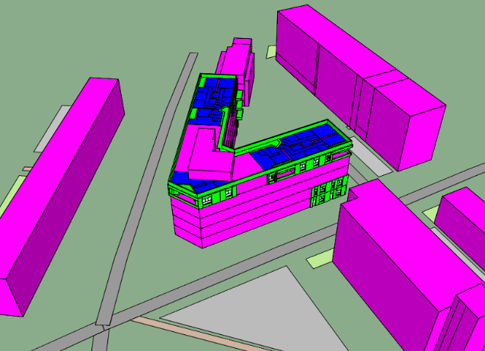 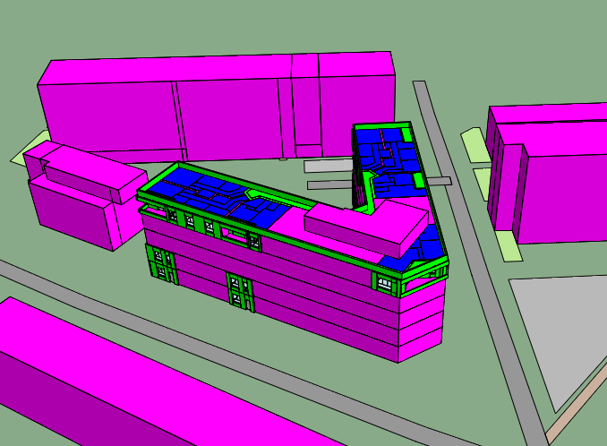

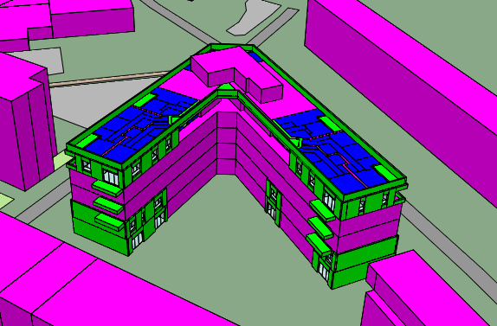

[Internal layouts of the modelled units, including space names as referenced in the results, e.g. as below]

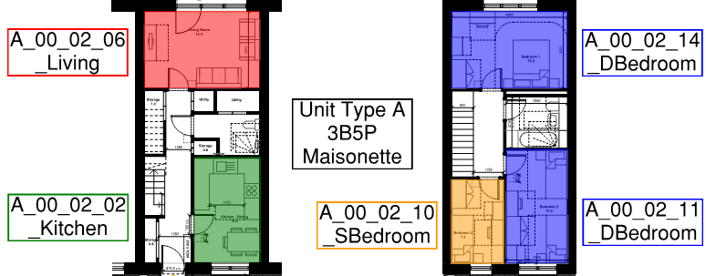

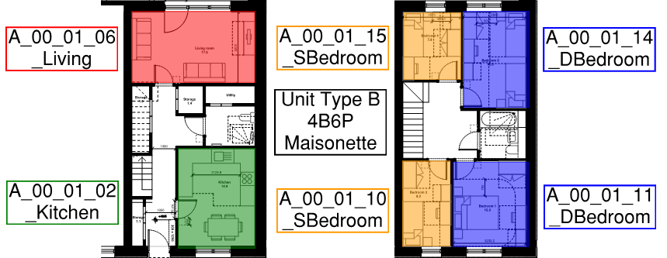

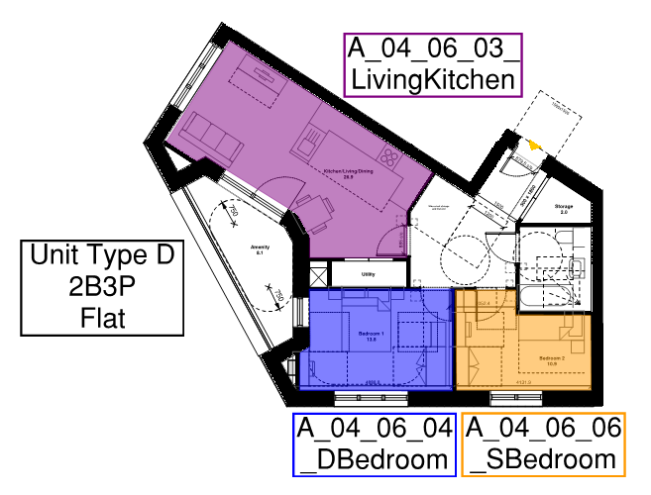

[etc for all modelled unit types (not necessarily all modelled units, if some types are repeated but have different orientations etc)]

## Fabric

The fabric properties used in the proposed design are set out in the table below. Properties used in additional tested design options are detailed in appendix A.

|  |  |  |  |
| --- | --- | --- | --- |
|  | U-value  (*W/m2/K)* | Thermal mass capacity  (kJ/m².K) | Construction Layers  (Outside to inside) |
| External Wall: Type 1 | *0.16* | *22.0* | *Layer 1 (material & thickness)*  *Layer 2 (material & thickness)*  *Layer 3 (material & thickness)*  *Etc…* |
| Ground Floor: Type 1 | *0.11* | *85.0* | *Layer 1 (material & thickness)*  *Layer 2 (material & thickness)*  *Layer 3 (material & thickness)*  *Etc…* |
| Exposed Roof: Type 1 | *0.11* | *8.8* | *Layer 1 (material & thickness)*  *Layer 2 (material & thickness)*  *Layer 3 (material & thickness)*  *Etc…* |
| Internal Wall: Type 1 | *1.8* | *8.8* | *Layer 1 (material & thickness)*  *Layer 2 (material & thickness)*  *Layer 3 (material & thickness)*  *Etc…* |
| Internal Ceiling/Floor: Type 1 | *1.1* | *8.8* | *Layer 1 (material & thickness)*  *Layer 2 (material & thickness)*  *Layer 3 (material & thickness)*  *Etc…* |
| External Glazing: Types 1-# | *1.2* | *N/A* |  |
| Opaque Door: Type 1 | *1.2* | *32.5* |  |

[Can add additional types to table if multiple were used in the proposed design (e.g. if certain rooms have additional thermal mass to ceilings, floors or walls and other rooms do not)]

[Description of thermal mass and where incorporated in the construction, especially if exposed].

The fabric types are assigned as per the figure shown below.

[Images of the IES model constructions applied (**excluding or including all different glazing and shading types, depending on the total number of these in the design**), with legend showing same naming convention as table above. E.g. as below. If multiple scenarios were tested with different fabric options, only show the final proposed design]

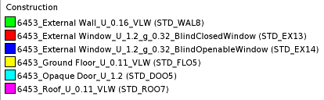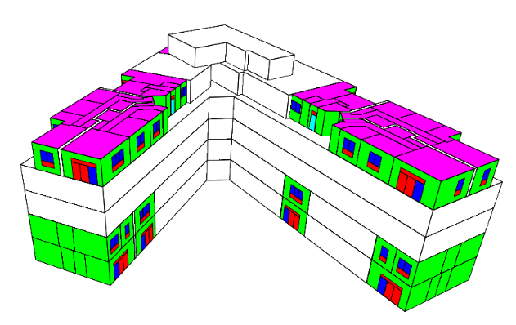

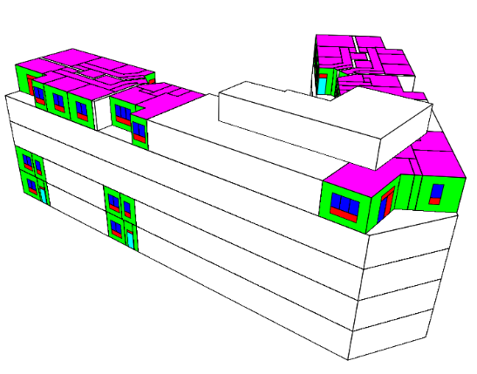 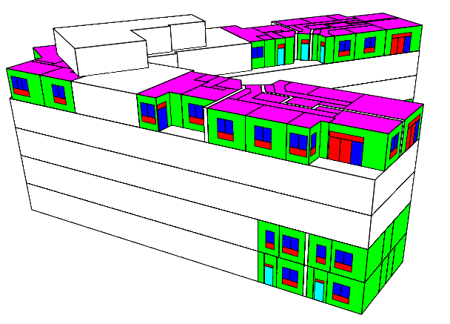

## Glazing and shading

[Description of the glazing extent (e.g., as per Architect Revit model dated dd/mm/yyyy, or as per images below), g-values and shading (e.g. description of external shading devices, or whether blinds have been included. If blinds included, the assumed solar transmittance/reflectance properties and usage profiles must be described and justified)]

The glazing and shading properties used in the proposed design are set out in the table below. Properties used in additional tested design options are detailed in appendix A. The types of glazing and shading combinations are assigned as per the figure shown [below/above].

[Tables of glazing types, with location, frame factor, g-values, external shading details, internal shading details and operating profiles]

|  |  |  |  |  |
| --- | --- | --- | --- | --- |
| Glazing & Shading Type | Applicable Floors | Applicable Orientations | Applicable Rooms | Applicable Glazing Types |
| GS1 | Ground | All | All | All |
| GS2 | 1F-4F | All | All | Windows |
| GS3 | 1F-4F | All | All | Glazed doors |

|  |  |  |  |  |
| --- | --- | --- | --- | --- |
| Glazing & Shading Type | Frame factor | g-value | External Shading Types | Internal Shading Types |
| GS1 | 10% | 0.40 | None | None |
| GS2 | 10% | 0.40 | ES1 | None |
| GS3 | 10% | 0.40 | ES1 | None |

|  |  |  |  |  |
| --- | --- | --- | --- | --- |
| External Shading Type | Type | Dimension / extent | Characteristics | Operation Profile |
| ES1 | Recess | 215mm deep |  | Fixed |
| ES2 | Shutters | 100% face area | 20% TF | SP1 |

TF = transmission factor

|  |  |  |  |  |
| --- | --- | --- | --- | --- |
| Internal Shading Type | Type | Dimension / extent | Characteristics | Operation Profile |
| IS1 | Roller blind | 100% face area | 0.4 SC, 0.3 SRF | SP1 |

SC = shading coefficient, SRF = Short-wave radiant fraction

|  |  |
| --- | --- |
| Operation Profile | Description |
| SP0 | Open continuously |
| SP1 | Closed continuously |
| SP2 | Closed if ii>250 W/m2 |

[If not included in the previous images, include here images of the IES model constructions applied (**showing only glazing and shading types**), with legend showing same naming convention as table above. E.g. as below. If multiple scenarios were tested with different glazing and shading options, only show the final proposed design]

## Ventilation

### Natural ventilation

[Description of the natural ventilation strategy for each room type, if applicable. E.g. via openable windows, rooflights and/or louvres]

[Description of the opening profiles, e.g, These windows open when the internal dry bulb temperature of the room exceeds 22°C and the room is occupied.]

[Description of any additional security and rain screen protection details included in the model and whether opening times have been extended as a result e.g. living room patio doors securely locked in a partially open position at night and the locked percentage of free area included in the model]

All internal doors are assumed to remain open during the day (enabling natural ventilation through the dwelling) but close at night. [This is TM59 standard – adjust if not true]

The natural ventilation opening properties used in the proposed design are set out in the table below. Properties used in additional tested design options are detailed in appendix A. The types of natural ventilation openings are assigned as per the figure shown below.

[Table of nat vent openings, types (e.g. side hung, top hung), free areas (but do they vary?), exposure types (separate table, dependant on façade orientation and floor?), opening profiles that are included in the model]

|  |  |  |  |  |
| --- | --- | --- | --- | --- |
| Natural Ventilation Opening Type | Applicable Floors | Applicable Orientations | Applicable Rooms | Applicable Opening Types |
| NV1 | Ground | All | All | All |
| NV2 | 1F-4F | All | All | Openable windows |
| NV3 | 1F-4F | All | All | Openable external doors |

|  |  |  |  |  |  |  |
| --- | --- | --- | --- | --- | --- | --- |
| Natural Ventilation Opening Type | Opening Type | Daytime  (9am-10pm) | | Night-time  (10pm-9am) | | Exposure type |
|  |  | Opening extent | Opening profile | Opening extent | Opening profile |  |
| NV1 | Side hung | 90° | VP1 | Closed | VP0 | Semi-exposed |
| NV2 | etc | etc | etc | etc | etc | etc |
| NV3 | etc | etc | etc | etc | etc | etc |

|  |  |
| --- | --- |
| Operation Profile | Description |
| VP0 | Closed continuously |
| VP1 | Open continuously |
| VP2 | Open if **Ti > 22°C** |
| VP3 | Open if **Ti > 22°C and To < 28°C** |

[Images of the IES model, showing the different opening types (with legend). e.g. as below]

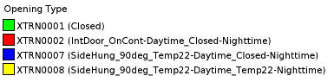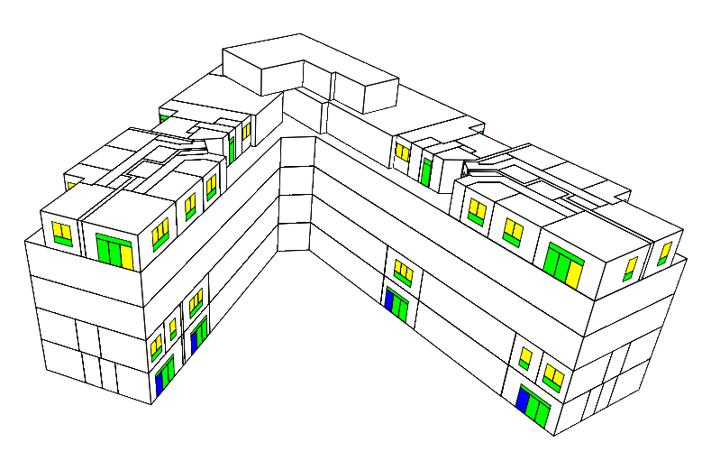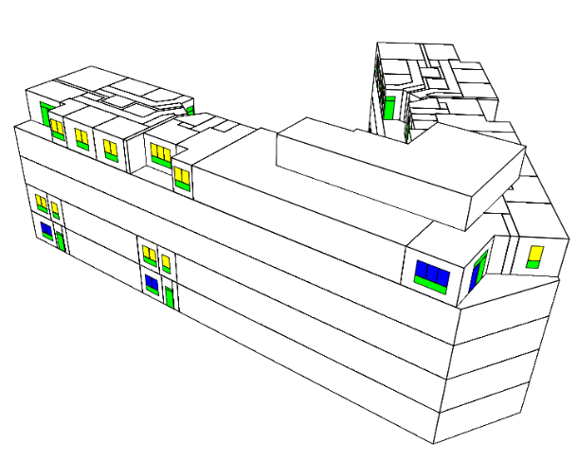 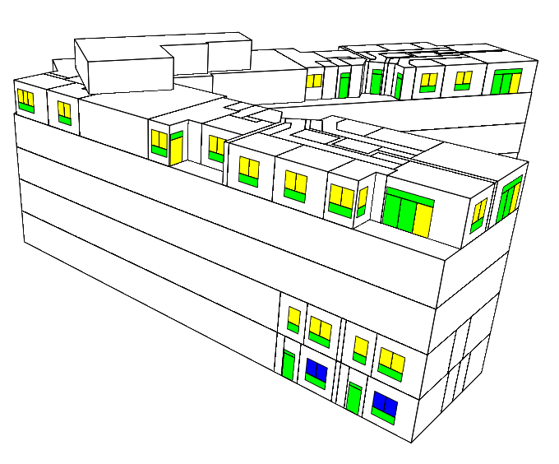

### Mechanical ventilation

[Description of the mech vent, e.g. A mechanical ventilation with heat recovery (MVHR) system is assumed, with air supplied to habitable rooms 24 hours a day. The ventilation rates meet the Building Standards minimum requirements.]

### Infiltration

An infiltration rate of 1.0 m³/h/m² at 50 Pa is included.

### Elevated air speed

An air speed of 0.1 m/s is assumed for the assessment. This is typical of natural ventilation and does not rely upon the installation of fixed ceiling fans.

## Internal gains

The model includes internal gains for double bedrooms, living rooms and kitchens as defined in TM59. The gains in each space vary throughout the day as shown in the images below. For example, the sensible occupancy gain for a 2-bedroom living room is calculated as 150 W x 0.75 factor = 112.5 W during the hours 9am-10pm and zero at other times.

[Description of how templates are assigned to any non-standard situation e.g. if there are two living spaces is the Living Room template applied to each? What is the resulting total occupancy at day and night?]

|  |  |  |  |  |  |  |
| --- | --- | --- | --- | --- | --- | --- |
| Unit Type | Room Type | Maximum occupancy  (persons) | Peak Occupancy Gains  (W) | | Peak Equipment Gains  (W) | Peak Lighting Gains  (W/m2) |
|  |  |  | Sensible | Latent | Sensible | Sensible |
| Studio | Studio | 2 | 150 | 110 | 450 | 2 |
| 1-bedroom dwelling | Living Room/Kitchen | 1 | 75 | 55 | 450 | 2 |
| Living Room | 150 |
| Kitchen | 300 |
| 2-bedroom dwelling | Living Room/Kitchen | 2 | 150 | 110 | 450 | 2 |
| Living Room | 150 |
| Kitchen | 300 |
| 3-bedroom dwelling | Living Room/Kitchen | 3 | 225 | 165 | 450 | 2 |
| Living Room | 150 |
| Kitchen | 300 |
| 4-bedroom dwelling | Living Room/Kitchen | 4 | 300 | 220 | 450 | 2 |
| Living Room | 150 |
| Kitchen | 300 |
| 1/2/3/4-bedroom dwelling | Single Bedroom | 1 | 75 | 55 | 80 | 2 |
| Double Bedroom | 2 | 150 | 110 |

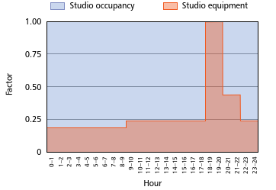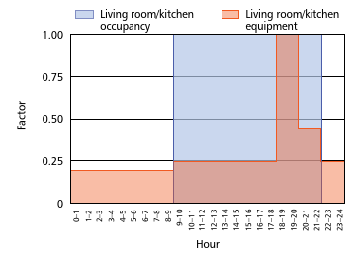

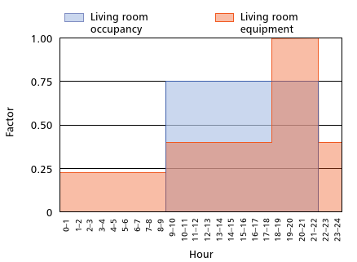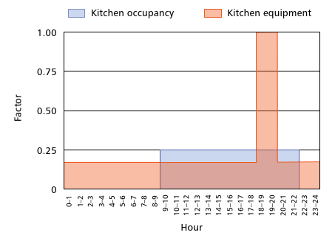

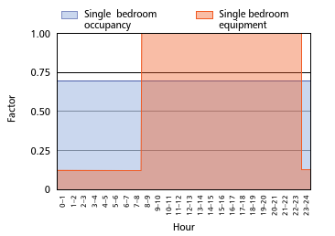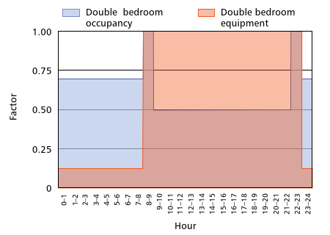

## Weather files

The following Design Summer Year (DSY) weather files have been tested, all for the [Weather file location] location:

### Minimum assessment

* DSY1 2020s, high emissions, 50% probability scenario

### Heatwave assessment

* DSY2 2020s, high emissions, 50% probability scenario
* DSY3 2020s, high emissions, 50% probability scenario

### Future climate assessment

* DSY1 2050s, high emissions, 50% probability scenario
* DSY1 2080s, medium emissions, 50% probability scenario

## Comfort category

Thermal comfort category II (as defined in CIBSE TM52:2013) has been assumed. This is suitable for new build homes that are not expected to be occupied by those who are particularly vulnerable to overheating.

## Tested Scenarios

Description of other tested scenarios?

Details can be found in appendix A?

# Results

The results of the analysis are shown in the table below.

## Minimum assessment

|  |  |  |  |  |
| --- | --- | --- | --- | --- |
|  | **Weather file:** | **DSY1 2020s, high emissions Scenario, 50%** | | |
| Dwelling & Room | TM59 Criterion:  Target: | a (%)  ≤ 3 % | B (%)  ≤ 1 % | Overall |
| A_00_01_02_Kitchen |  | 0.00 | N/A | PASS |
| A_00_01_06_Living |  | 0.05 | N/A | PASS |
| A_00_01_10_SBedroom |  | 0.00 | 0.00 | PASS |
| Etc |  | 0.54 | 0.00 | PASS |
| Etc |  | 0.35 | 0.00 | PASS |

## Heatwave assessment

|  |  |  |  |  |
| --- | --- | --- | --- | --- |
|  | **Weather file:** | **DSY2 2020s, high emissions Scenario, 50%** | | |
| Dwelling & Room | TM59 Criterion:  Target: | a (%)  ≤ 3 % | B (%)  ≤ 1 % | Overall |
| A_00_01_02_Kitchen |  | 0.00 | N/A | PASS |
| A_00_01_06_Living |  | 0.05 | N/A | PASS |
| A_00_01_10_SBedroom |  | 0.00 | 0.00 | PASS |
| Etc |  | 0.54 | 0.00 | PASS |
| Etc |  | 0.35 | 0.00 | PASS |

|  |  |  |  |  |
| --- | --- | --- | --- | --- |
|  | **Weather file:** | **DSY3 2020s, high emissions Scenario, 50%** | | |
| Dwelling & Room | TM59 Criterion:  Target: | a (%)  ≤ 3 % | B (%)  ≤ 1 % | Overall |
| A_00_01_02_Kitchen |  | 0.00 | N/A | PASS |
| A_00_01_06_Living |  | 0.05 | N/A | PASS |
| A_00_01_10_SBedroom |  | 0.00 | 0.00 | PASS |
| Etc |  | 0.54 | 0.00 | PASS |
| Etc |  | 0.35 | 0.00 | PASS |

## Future climate assessment

|  |  |  |  |  |
| --- | --- | --- | --- | --- |
|  | **Weather file:** | **DSY1 2050s, high emissions Scenario, 50%** | | |
| Dwelling & Room | TM59 Criterion:  Target: | a (%)  ≤ 3 % | B (%)  ≤ 1 % | Overall |
| A_00_01_02_Kitchen |  | 0.00 | N/A | PASS |
| A_00_01_06_Living |  | 0.05 | N/A | PASS |
| A_00_01_10_SBedroom |  | 0.00 | 0.00 | PASS |
| Etc |  | 0.54 | 0.00 | PASS |
| Etc |  | 0.35 | 0.00 | PASS |

|  |  |  |  |  |
| --- | --- | --- | --- | --- |
|  | **Weather file:** | **DSY1 2080s, medium emissions Scenario, 50%** | | |
| Dwelling & Room | TM59 Criterion:  Target: | a (%)  ≤ 3 % | B (%)  ≤ 1 % | Overall |
| A_00_01_02_Kitchen |  | 0.00 | N/A | PASS |
| A_00_01_06_Living |  | 0.05 | N/A | PASS |
| A_00_01_10_SBedroom |  | 0.00 | 0.00 | PASS |
| Etc |  | 0.54 | 0.00 | PASS |
| Etc |  | 0.35 | 0.00 | PASS |

## Results comparison: Proposed design option

[For the ‘proposed’ design option (as detailed in section 4), provide graphs for:

For all sampled (i.e. modelled) rooms

% of sampled rooms passing (Criteria a & b, criterion a only, criteria b only) vs:

Weather file

Elevated air speed

Selected example rooms (as defined by IES group?)

External air temp, internal operative temperature and max. operative temp vs time for:

-Summer months (May-Sept inclusive)

-Peak week (based on peak external air temp)

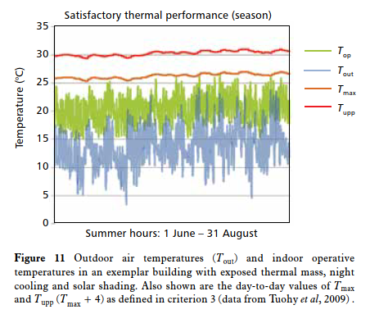

One graph for each tested weather file?

## Results comparison: Other tested design options

TM59 criteria score vs selected modelled scenarios

Criteria a & b for bedrooms and studios

Criteria a only for kitchens, living rooms

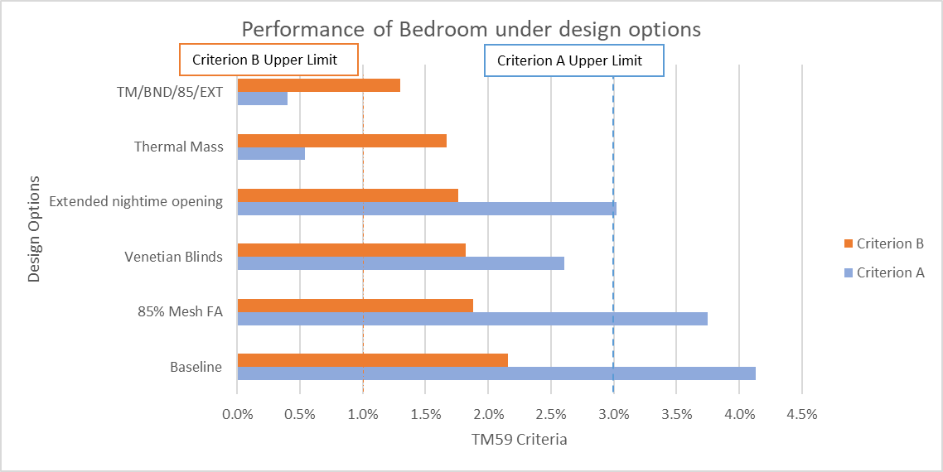

Air Speed available without fixed room fans

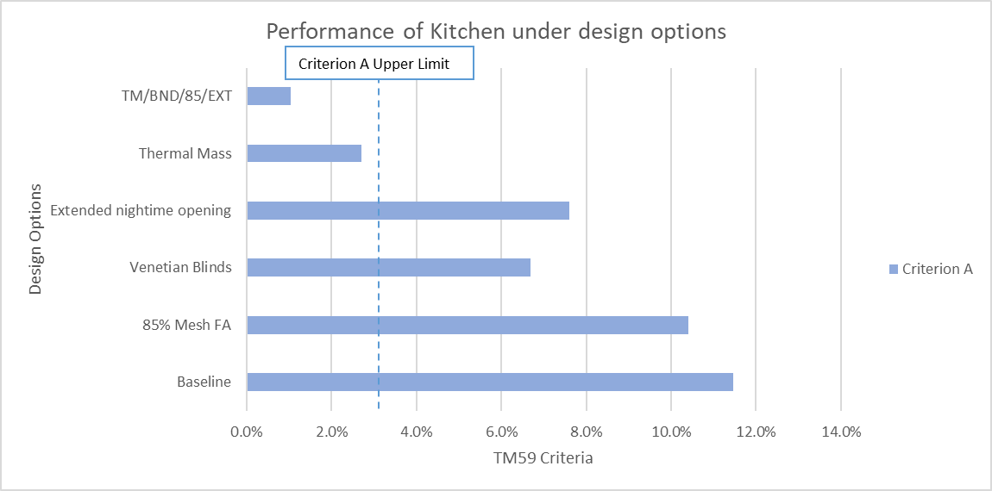

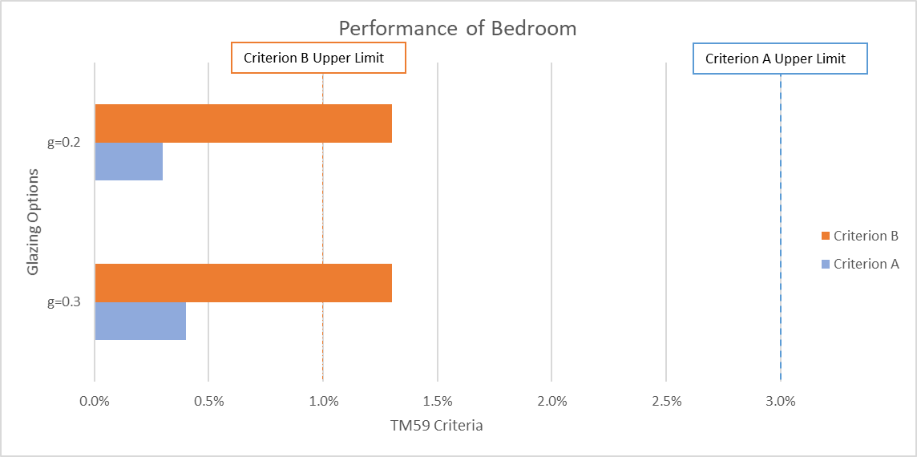

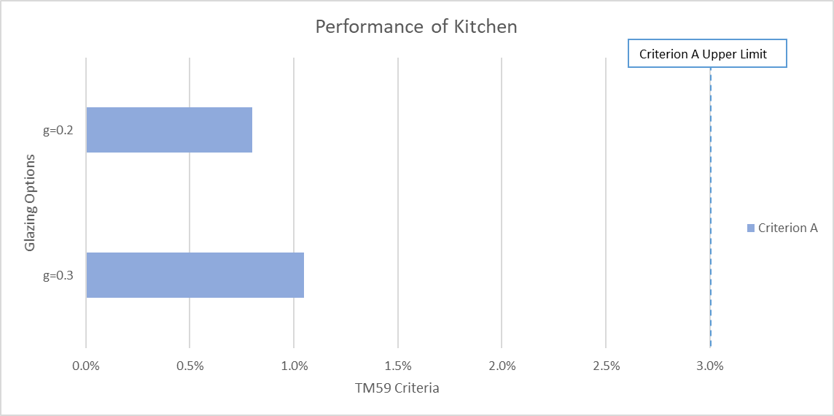

# Conclusions and Recommendations

[Description of results and recommendations, including a description of the design features a pass depends on e.g. the inclusion of glazing with g-value below 0.x, reduced window sizes, external shading devices etc].

# Appendices

|  |  |  |  |  |  |  |  |  |  |  |
| --- | --- | --- | --- | --- | --- | --- | --- | --- | --- | --- |
|  | **DSY1 2020s** | | **DSY2 2020s** | | **DSY3 2020s** | | **DSY1 2050s** | | **DSY1 2080s** | |
| Room | Crit. a | Crit. b | Crit. a | Crit. b | Crit. a | Crit. b | Crit. a | Crit. b | Crit. a | Crit. b |
| Kitchen | 0.00 | N/A | 0.20 | N/A | 0.05 | N/A | 0.15 | N/A | 0.35 | N/A |
| Living / Dining | 0.05 | N/A | 0.35 | N/A | 0.15 | N/A | 0.35 | N/A | 0.65 | N/A |
| Bedroom 1 | 0.00 | 0.00 | 0.03 | 0.00 | 0.00 | 0.00 | 0.00 | 0.00 | 0.00 | 0.03 |
| Bedroom 2 | 0.54 | 0.00 | 0.70 | 0.03 | 0.79 | 0.00 | 1.09 | 0.03 | 1.36 | 0.03 |
| Bedroom 3 | 0.35 | 0.00 | 0.60 | 0.03 | 0.60 | 0.03 | 0.90 | 0.03 | 1.22 | 0.09 |

Note, green results = **Pass**, red results = **Fail**